 | E.G.S. Pillay Engineering College  An Autonomous Institution Affiliated to Anna University, Chennai | Approved by AICTE, New Delhi  Accredited by NBA T1 (B.E. – CIVIL, CSE, ECE, EEE, MECH & B.Tech – IT)  Accredited by NAAC with A++ Grade | One among Top 300 Engineering Institutions in India (NIRF-24)  Old Nagore Road, Thethi, Nagore Village, Nagapattinam – 611002, Tamil Nadu, India
DEPARTMENT OF INFORAMTION TECHNOLOGY
“Hands-on workshop on Git and SDLC Fundamentals”
SAMPLE PHOTOS
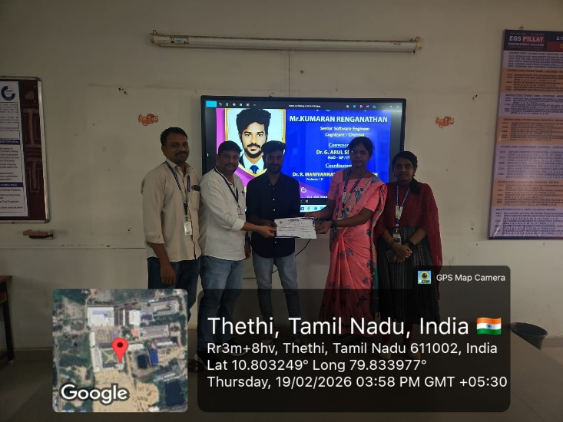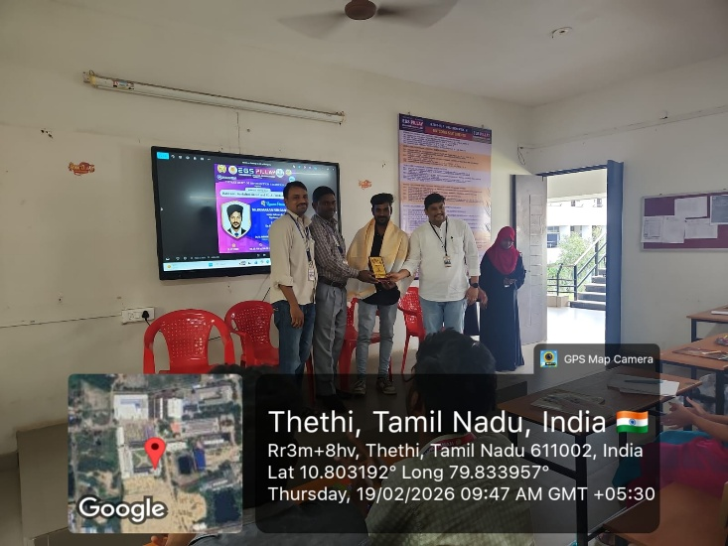
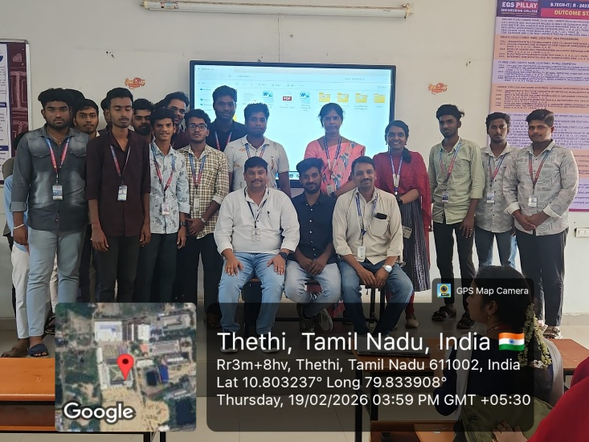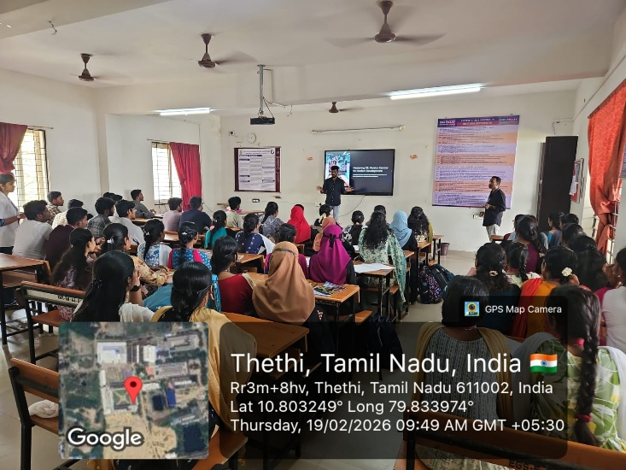
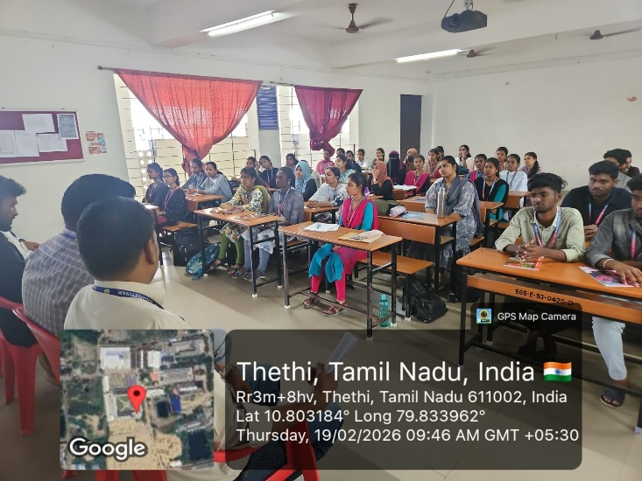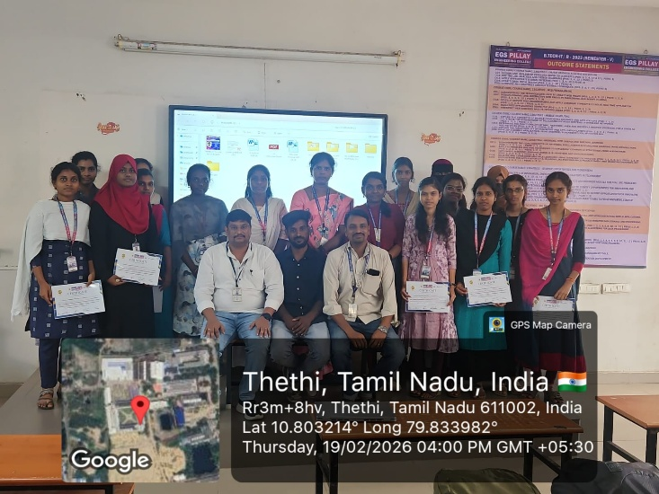

Coordinators
(Dr. R. Manivannan)
(Mr. A. Rajesh)

HOD / IT
(Dr. G. Arul Selvan)

